**Software Requirements Specification**

**Project Topic:** Online Fashion Rental website.

**1. Introduction**

The online fashion rental website (Fashion Fusion) is a platform that allows users to rent fashionable items for a specific period of time. The website offers a range of clothing items and accessories for men and women from various brands. The website has several functionalities, including user registration and login, item catalogue, search and filtering, item detail page, booking system, payment processing, shipping and return management and rating and review system. Users can browse and select items, book them for a specified time period, make payments, and receive the items through shipping. The website also allows customers to rate and review the items they rent and provide feedback on their rental experience. The goal of the website is to provide an affordable and convenient option for users to rent fashionable items instead of buying them.

* 1. **Purpose**

The purpose of the website, Online Fashion Rental website (Fashion Fusion) is to provide an online platform for fashion enthusiasts to rent high-end designer clothing, accessories, and statement pieces**.**

The objective of the website is to provide an affordable and convenient option for users to rent fashionable items instead of buying them.

* 1. **Intended Audience**

The main system user roles are as follows:

* User (Customer)
* Rental items Provider.
* Application Admin
  1. **Intended Use**

The intended use for Fashion Fusion, is to provide an online platform for users to browse, select, and rent fashion items for various purposes.

* 1. **Scope**

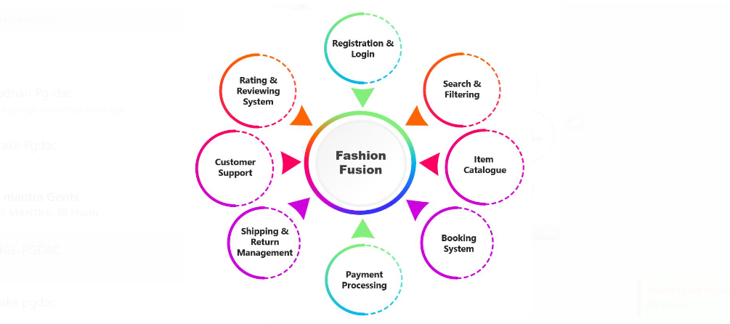

* 1. **Definitions and Acronyms**

**Definitions:**

1. **User:** Member stands for a registered user of the system. The person needs to register with the system, providing the required data.
2. **Rental Item provider:** The providers typically have a collection of items that they make available for temporary use in exchange for a rental fee.
3. **Application Admin:** Application Admin refers to an individual or a team responsible for managing and administering an application. They are typically responsible for various tasks related to the application's operation, configuration, security, and user management.

**2. Overall Description (Client acceptance + Development team)**

A Fashion Fusion is a platform that allows users to rent fashion items from a variety of brands and designers. Also, users can register to provide items on rent. The website typically features a searchable catalogue of items, as well as filters to help users find the perfect look. Users can rent items for a specified period of time, review the product. Also, the website will handle all of the logistics, such as shipping, returning.

**2.1 User Need**

1. A wide variety of fashion items to choose from.
2. Affordable prices.
3. Convenient rental process.
4. Excellent customer service.
5. A variety of payment options.
6. The ability to rent items for some period of time.
7. The ability to return items early or late without penalty.
8. The ability to exchange items if they are not the right size or style.

**2.2 Assumptions and Dependencies (Design/Development team)**

1. Users need to create an account and be registered with the Fashion Fusion Website before accessing its features and services.
2. The fashion rental app offers different types of memberships with varying benefits, privileges, and fees.
3. The fashion rental app provides a clear and transparent overview of the benefits, features, and costs associated with each customer type.

**3. System Features and Requirements**

**3.1 Functional Requirements**

The complete functional modules of the application include the following:

1. **Registration and Login**

Allow user to create an account & sign in using email and password or other social accounts. Verify user identity through email verification and two-factor authentication.

1. **Search And Filtering**

Using this feature using can search for a product & can filter the products using different entities such as price range, new arrivals, colour etc.

1. **Item** **Catalogues**

This module allows user to see items catalogue according to occasional base.

1. **Booking** **System**

In this module, the user will able to add personal details and address and book the product by selecting the duration to rent the product according to its pricing.

1. **Payment** **Processing**

Using this, the user will able to choose payment method according to his convenience such as UPI, Cash On Delivery, Card Payment etc.

1. **Shipping** **and** **Return** **Management**

The door step delivery will be provided by the Courier service provider within 5 to 7 days. And after duration period is over then door step pickup will be provided if user has to return or he can extend the time period.

1. **Customer Support**

24*7 customer support will be provided for any queries regarding shipment or tracking the product or to know the details of the product.

1. **Ratings and Review System**

This system allows user to rate the products which he purchased so that other users can get assurance about that particular product**.**

**3.2 External Interface Requirements**

1. **Payment Gateway:**
2. Secure payment gateway integration: Integrate a reliable and secure payment gateway to process transactions, supporting various payment methods. Pricing and billing: Calculate rental charges, additional fees (such as cleaning or late fees), and provide clear billing statements to users. Payment reminders: Send automated reminders for upcoming or overdue payments.
3. Inventory Management: Item catalogue management: Provide an interface for administrators to manage and update the inventory, including adding new items, updating availability, and removing rented or unavailable items.
4. Size and availability tracking: Keep track of item availability based on size, style, and other attributes to ensure accurate information is displayed to users.
5. **Communication and Support:**
6. Include contact information and options for users to reach customer support or ask questions regarding rentals, returns, or other inquiries.
7. Chat or messaging feature: Provide a communication channel for users to communicate with customer support or with other users, such as for inquiries, size recommendations, or item requests.
8. **Integration with Third-Party Services:**
9. Integrate with external services such as shipping providers for tracking deliveries, inventory management systems for real-time availability, and analytics tools for monitoring website performance and user behaviour.

**3.3 System Features**

The Fashion Fusion website will be responsive and optimized for different devices and screen sizes, including desktop computers, smartphones, and tablets. The user interface will adapt to provide an optimal viewing and browsing experience.

**3.4 Non-Functional Requirements**

* 1. **Security:**

Ensure that the platform is secure and uses encryption to protect user data, including personal information and payment details.

Ensure that the platform is compliant with data privacy laws such as GDPR and CCPA, protecting user data and providing users with control over their data. Implement a privacy policy and terms of service that outline how user data is collected, used, and protected.

* 1. **Performance:**

Ensure that the platform is fast and responsive, with quick load times for pages and search results. Ensure that the platform can handle high traffic volumes during peak rental periods such as occasions & festivals.

* 1. **Scalability:**

Design the platform to be scalable and able to handle a growing number of users. Implement load balancing and other techniques to distribute traffic and prevent overload on the server.

* 1. **Reliability:**

Ensure that the platform is reliable and able to handle a high volume of traffic without crashing or experiencing downtime. Implement backup and recovery systems to ensure that data is not lost in the event of a system failure.

* 1. **Accessibility:**

Implement features such as keyboard navigation to improve accessibility.

* 1. **Usability:**

Ensure that the platform is easy to use and navigate, with intuitive user interfaces and clear instructions for tasks such as adding a product to cart for rent & wish list also.

* 1. **Maintainability:**

Design the platform with maintainability in mind, making it easy to update and modify as needed. Use modular and well-structured code to make it easy to identify and fix bugs and add new features.